Castell Alun Friends Association – Christmas Order Form 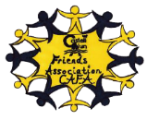
Christmas Trees:
☐Nordmann fir (non-drop) 4 – 5ft £25
☐Nordmann fir (non-drop) 6 - 7ft £30
☐Nordmann fir (non-drop) 7 – 8ft £40
Christmas Wreaths: Please note, wreaths are handmade and so may vary slightly from images
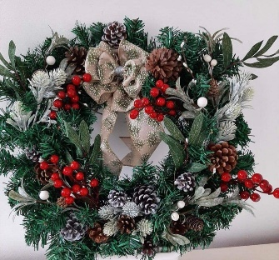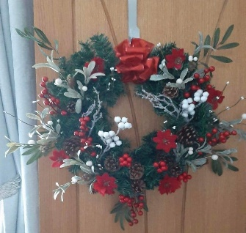
☐Wreath A £30 ☐Wreath B £30
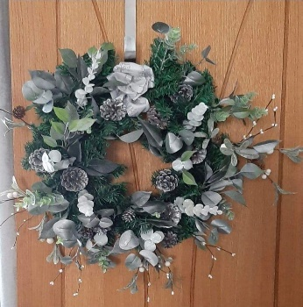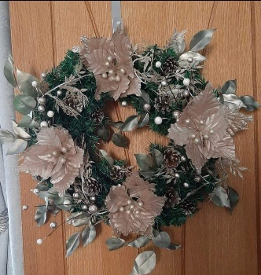
☐Wreath C £30 ☐ Wreath D £30
Customer Details:
Name | Click here to enter text.
Contact Number | Click here to enter text.
Email | Click here to enter text.
Address | Click here to enter text.

